**How to Create IBM Cloud Account**

1. You can create the account either through Mobile browser or System browser
2. Click on <https://ibm.biz/BdqH5v> or <http://bit.ly/CFCIndia>
3. Put your email id and click on

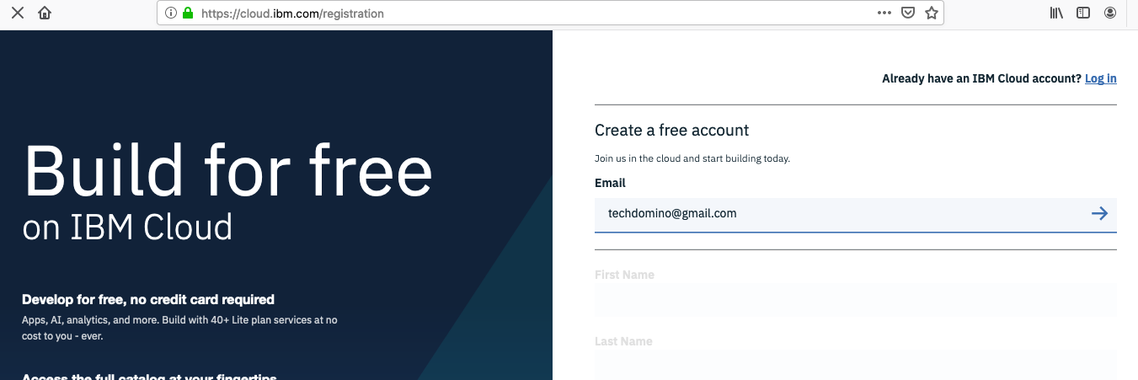

1. System will validate your ID and below fields will activate after validation
2. Please provide “First Name”, “Last Name”, “Country”, “Password”, select preferred options and click on “Create Account”

1. You will receive below message. Go to your mail box and confirm the account activation

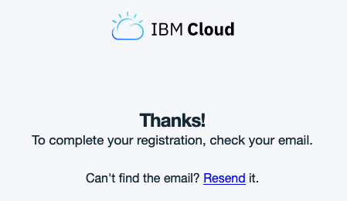

1. In case you already have Cloud account, click on <https://cloud.ibm.com/login>
2. Provide IBM ID (Email ID) which was used to cloud account registration
3. Put password. Use reset password in case you have forgotten the password and check for password reset instructions sent over email

**Common Issues**

**Issue** - You might encounter error message while creating cloud account “Registration Failure”

**Solution** – Please use different Internet service provider. For example if you encountered the error while using College WIFI, please use your personal mobile data for registration

If error persists – please delete browser cache and initiate registration through “Incognito Mode” on Browser

**Please contact Mritunjay (**[**mritunjay@in.ibm.com**](mailto:mritunjay@in.ibm.com)**) call or whatsapp on 9845284911 in case of issue**